Lab 08: WHILE LOOPS

# Name: Hassan Shahzad

# Class: BSCS 7C

# CMS ID: 211798

## TASK 01:

#define _CRT_SECURE_NO_WARNINGS

#include <stdio.h>

#include <stdlib.h>

int main()

{

int pin = 1234, entry;

printf( "WELCOME TO THE SEECS BANK.\n" );

printf( "ENTER YOUR PIN: " );

scanf( "%d", &entry );

while ( entry != pin )

{

printf( "\nINCORRECT PIN. TRY AGAIN.\n" );

printf( "ENTER YOUR PIN: " );

scanf("%d", &entry);

}

printf("\nPIN ACCEPTED. YOU NOW HAVE ACCESS TO YOUR ACCOUNT.");

return EXIT_SUCCESS;

}

//--------------------------------------------------------------------------------------------------------------------------

// Q1): In both while and if loop, the condition is checked before the execution of a block of code inside.

// Q2): While is a controlled loop whereas if is a counter controlled loop. When condition is true, if condition is executed only once whereas while loop keep on executing until the condition is false.

// Q3): If scanf statement is omitted from while statement and the pin code is entered wrong then the program will print INCORRECT PIN. TRY AGAIN. ENTER YOUR PIN infinitely.

//--------------------------------------------------------------------------------------------------------------------------

## OUTPUT:

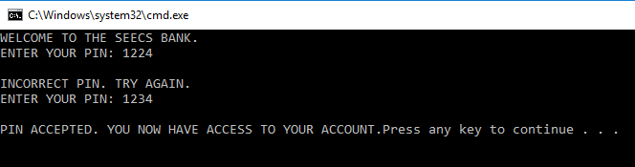

## TASK 02:

#define _CRT_SECURE_NO_WARNINGS

#include <stdio.h>

int main()

{

int secret = 6; // declaring secret

int guess; // declaring guess

printf(" I have chosen a number between 1 and 10. Try to guess it. "); // asking user to input a number

scanf("%d", &guess);

printf("Your guess: %d\n", guess); // tells the user about his guess

while (secret != guess)

{

printf(" That is incorrect. Guess again. \n"); // tells the user that he has entered a wrong value

printf(" I have chosen a number between 1 and 10. Try to guess it. "); // again asks the user to enter a value

scanf("%d", &guess);

printf("Your guess: %d\n", guess);

}

printf("That's right! You guessed it.\n"); // tells the user that he has entered correct value

}

## OUTPUT:

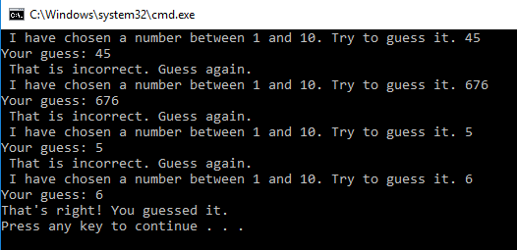

## TASK 03:

#define _CRT_SECURE_NO_WARNINGS

#include <stdio.h>

int main()

{

// random number from 1 to 6

srand(time(NULL));

int RandDice1 = 1 + rand() % 10; // declaring variables

int RandDice2 = 1 + rand() % 10;

int total;

printf("HERE COMES THE DICE! \n\n"); // displaying HERE COMES THE DICE

printf("Roll #1: %d\n", RandDice1); // displaying roll #1

printf("Roll #2: %d\n", RandDice2); // displaying roll #2

total = RandDice1 + RandDice2; // assigning value to total

printf("The total is = %d\n\n", total);

while (RandDice1 != RandDice2) // condition checking

{

RandDice1 = 1 + rand() % 10;

RandDice2 = 1 + rand() % 10;

printf("Roll #1: %d\n", RandDice1);

printf("Roll #2: %d\n", RandDice2);

total = RandDice1 + RandDice2;

printf("The total is = %d\n\n", total);

}

return 0;

}

## OUTPUT:

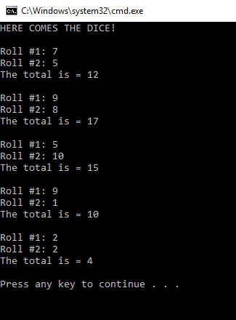

## TASK 05:

#define _CRT_SECURE_NO_WARNINGS

#include <stdio.h>

int main()

{

char message[80];

int a = 10, count;

printf("Type in a message, and I'll display it several times .\n");

printf("Message: ");

gets(message);

printf("How many times? ");

scanf("%d", &count);

int n = 0;

while (n < count)

{

printf("%d. %s\n", ( n + 1 )*10, message);

a += 10;

n++;

}

return 0;

}

// --------------------------------------------------------------------------------

// Q1) n++ increments the value of n. The loop goes on forever as condition never satisfies and the message number stays one.

// ---------------------------------------------------------------------------------

## OUTPUT:

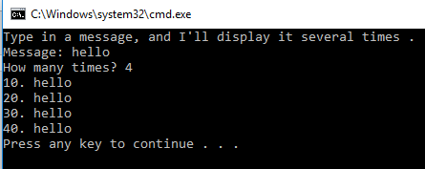

## TASK 06:

#define _CRT_SECURE_NO_WARNINGS

#include <stdio.h>

#include <stdlib.h>

int main()

{

int pin = 1234;

int tries = 0;

int entry = 0;

int maxtry = 4;

printf("WELCOME TO THE SEECS BANK.\n");

printf("\nENTER YOUR PIN: ");

scanf(" %d", &entry);

tries++;

while (entry != pin && tries < maxtry)

{

printf("\nINCORRECT PIN. TRY AGAIN.\n");

printf("ENTER YOUR PIN: ");

scanf(" %d", &entry);

tries++;

}

if (entry == pin)

printf("\nPIN ACCEPTED. YOU NOW HAVE ACCESS TO YOUR ACCOUNT.\n");

else if (tries >= maxtry)

printf("\nYOU HAVE RUN OUT OF TRIES. ACCOUNT LOCKED.\n");

return EXIT_SUCCESS;

}

## OUTPUT:

## 

## TASK 07:

#define _CRT_SECURE_NO_WARNINGS

#include <stdio.h>

#include <stdlib.h>

int main()

{

int guess, tries, n = 2;

tries = 1;

srand(time(NULL));

int random = 1 + rand() % 100;

printf("I am thinking of a number between 1-100. You have 7 guesses.\n"); printf("First Guess: "); scanf("%d", &guess); while ((guess != random) && (tries < 7)) { if (guess > random) printf("Sorry, you are too high.\n"); else printf("Sorry, you are too low.\n");

printf(" Guess # %d: ", n);

scanf("%d", &guess);

n++; tries++;

}

if (guess == random)

printf("You guessed it!\n");

else

printf("No more tries left.\n");

return 0;

}

## Output:

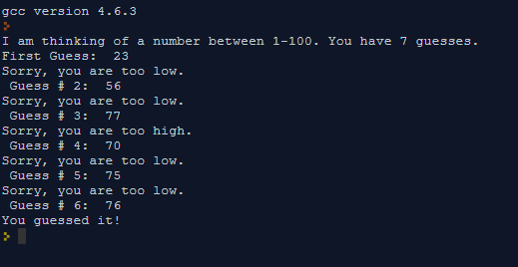

## TASK 08:

#define _CRT_SECURE_NO_WARNINGS

#include <stdio.h>

#include <stdlib.h>

int main()

{

int a, total;

printf("I will add up the numbers you give me.\n");

total = 0;

printf("Number: ");

scanf("%d", &a);

total = total + a;

printf("The total so far is %d\n", total);

while ( a != 0 )

{

printf("Number: ");

scanf("%d", &a);

total = total + a;

printf("The total so far is %d\n", total);

}

printf("\n\n");

}

## Output:

